**PRACTICAL: 1**

**AIM:**

Compare Kali Linux and Parrot Security Operating System.

**THEORY:**

• Parrot OS is a GNU/Linux distribution based on Debian that aids IT teams of all sizes in the development of software and in carrying out security-related tasks like computer forensics, penetration testing, cryptography, hacking, or reverse engineering.

• Parrot is designed to offer a collection of penetration testing tools that can be used for vulnerability analysis, attack mitigation, and security research. It is intended for computer forensics, anonymous web browsing, vulnerability evaluation, and mitigation.

• In addition to several hundred tools aimed at different Information Security jobs, such as Penetration Testing, Security Research, Computer Forensics, Reverse Engineering, Vulnerability Management, and Red Team Testing, Kali Linux also has industry-specific modifications.

• If you are a web developer in particular, Kali Linux is a preferred choice for programmers, developers, and security researchers. Additionally, Kali Linux performs smoothly on low-power gadgets like the Raspberry Pi, making it an ideal OS for those gadgets.

• We can see that due to ParrotOS's lighter weight compared to Kali Linux, it clearly wins when it comes to hardware needs. Thanks to the developers' usage of the Matte-Desktop-Environment, not only does it run more efficiently with less RAM needed, but the complete installation is also light.

• Parrot OS can function with as little as 15 GB of storage, whereas Kali Linux needs around 20 GB. Parrot OS may function with as little as 300 MB RAM, but Kali requires a minimum of 1 GB RAM. Parrot OS does not require hardware acceleration via the GPU, unlike Kali Linux does.

• Parrot OS can be used by hackers for a variety of tasks, including vulnerability analysis, penetration testing, computer forensics, and more.

Features of Kali OS

* Free
* Multi language assistance
* Customizable
* Pre installed tools and programs

**OUTPUT:**

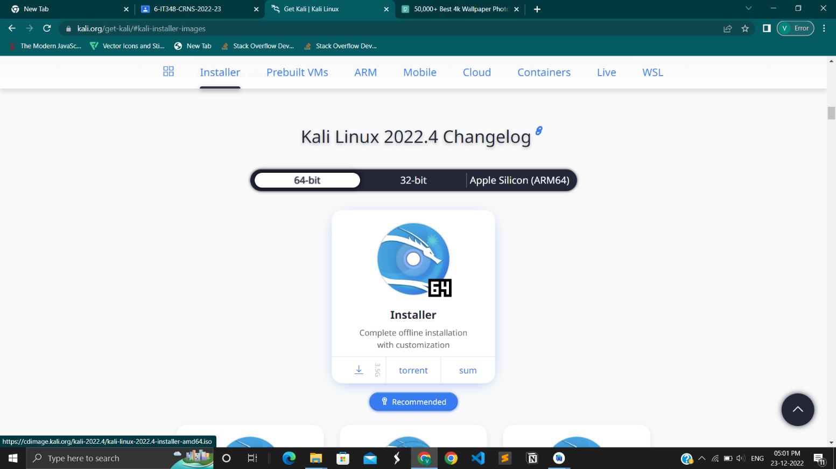

1.1 Installation of Kali Os from its official website <https://www.kali.org/>

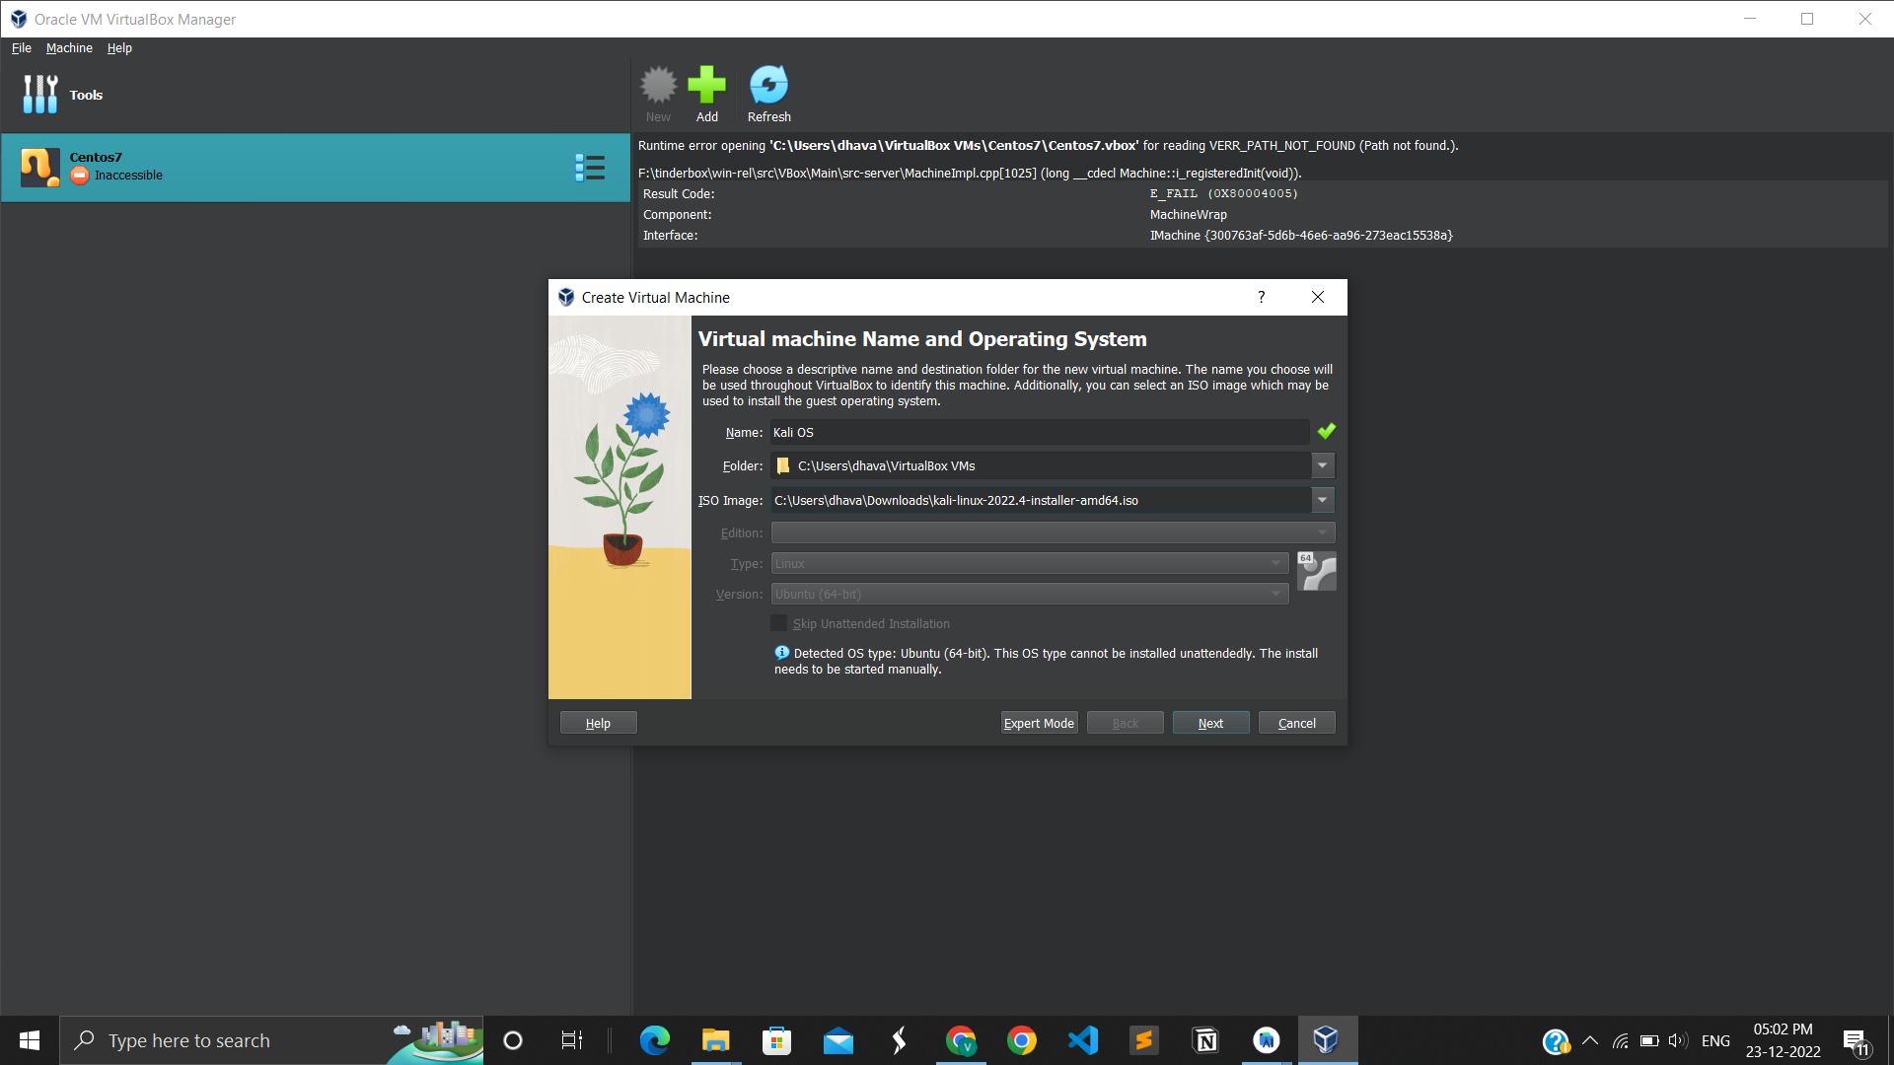

1.2 Give Folder and ISO image address

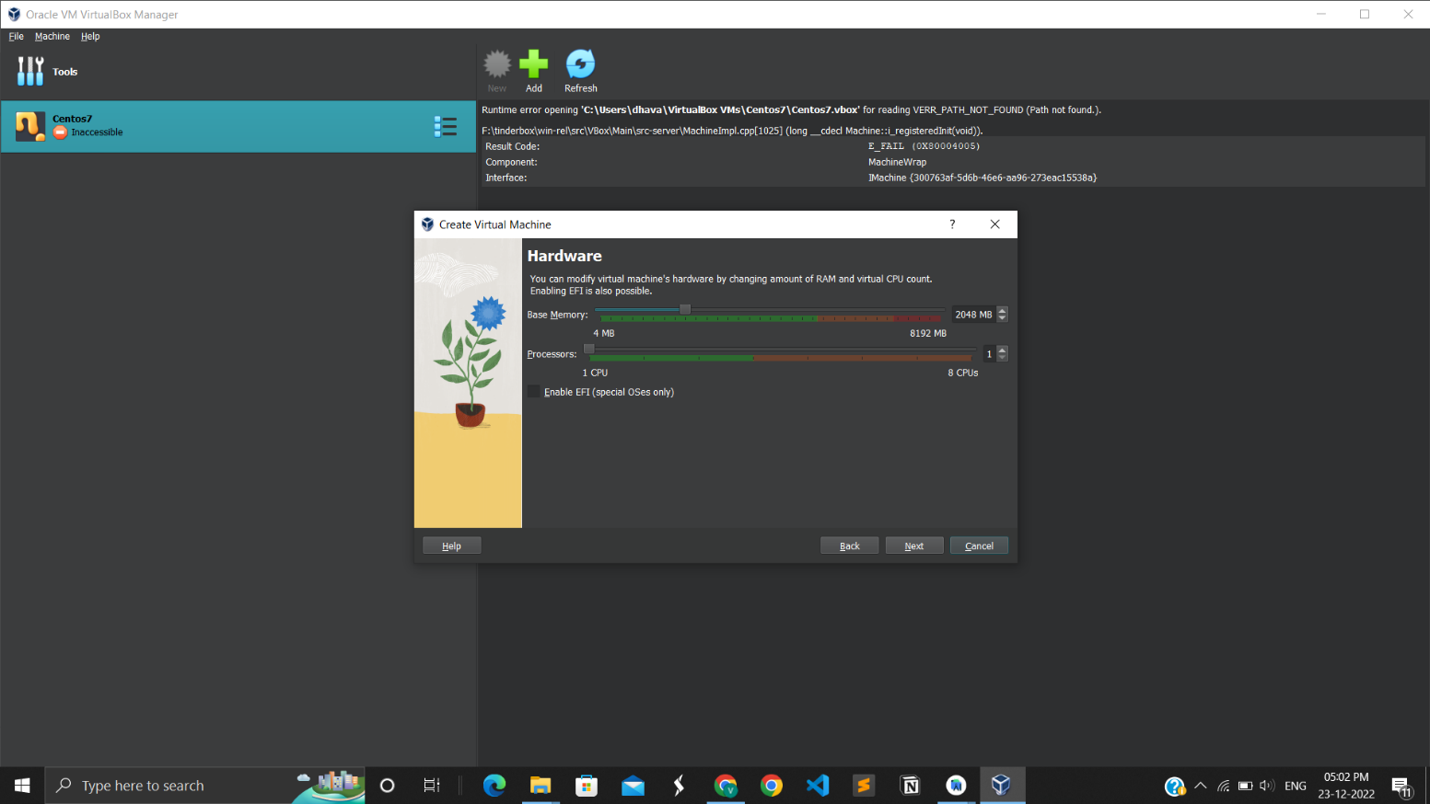

1.3 Adjust Hardware configuration and processors.

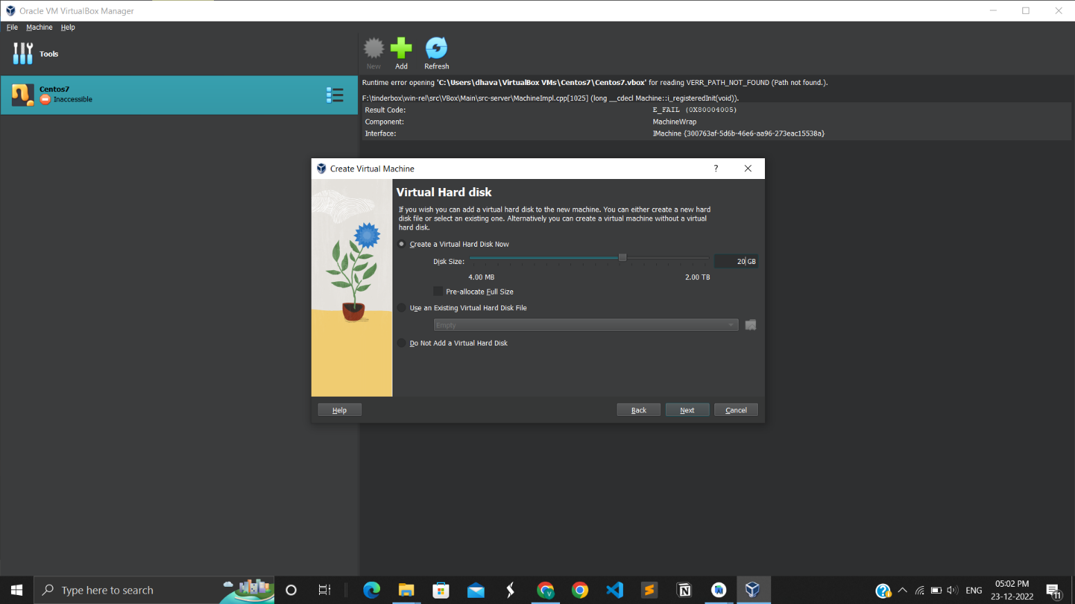

1.4 Adjust Virtual Hard disk .

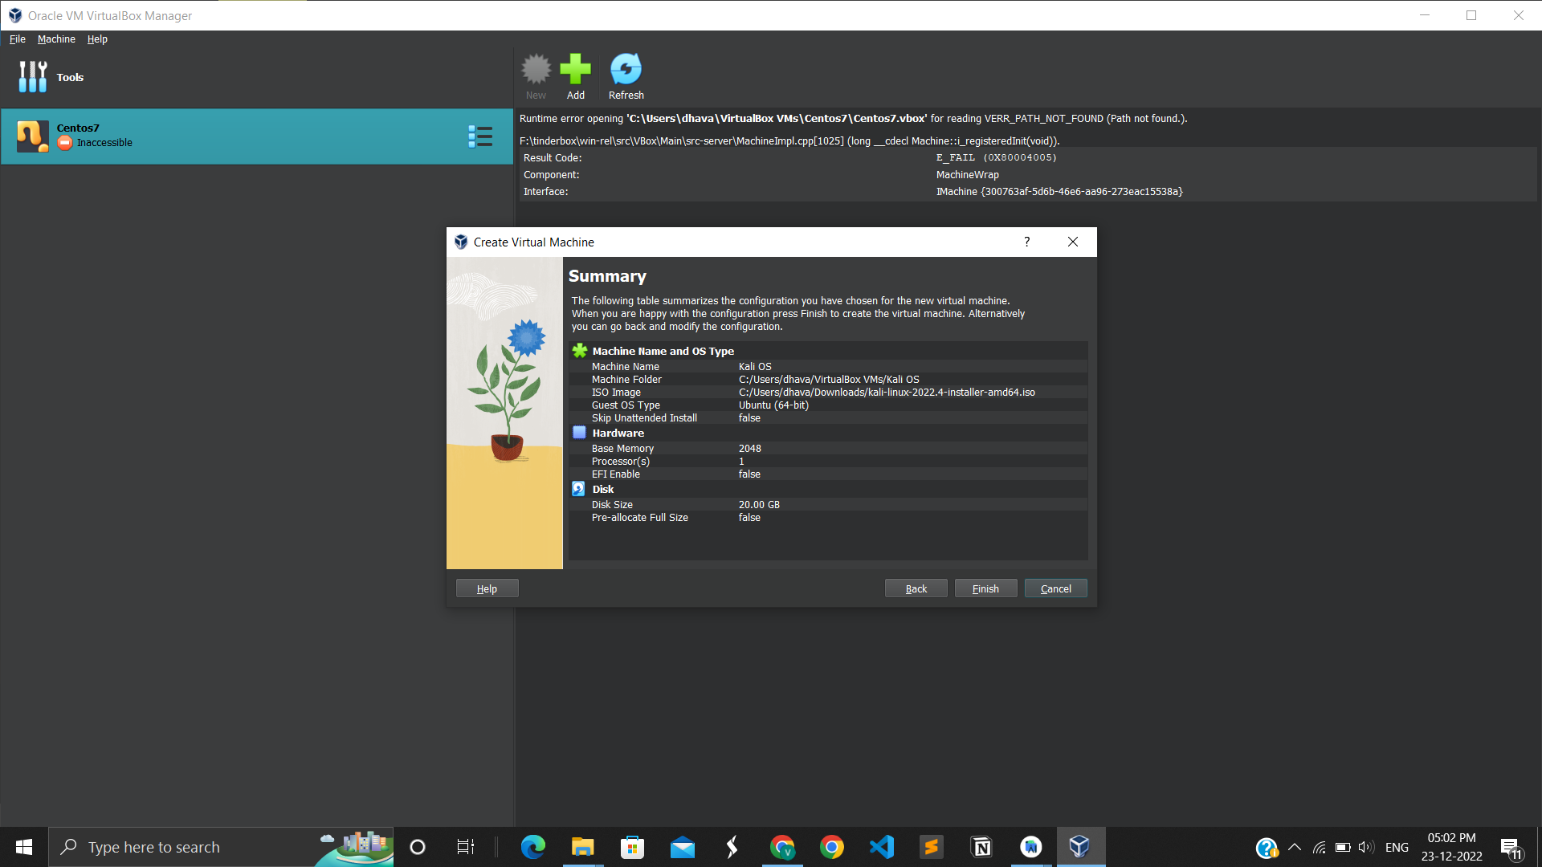

1.5 Summary of Kali OS

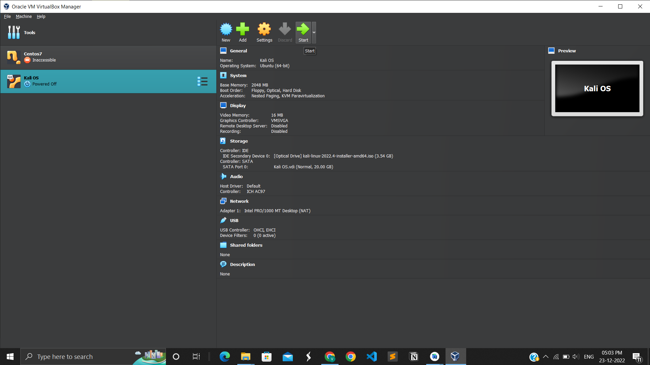

1.6 Press start to launch Kali OS

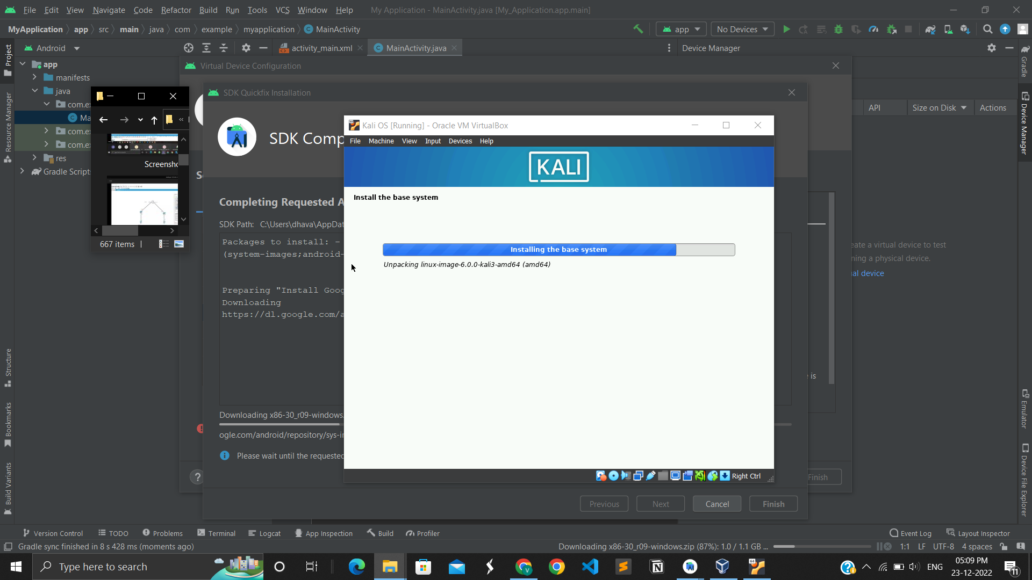

1.7 Installing Kali OS and their others Packages

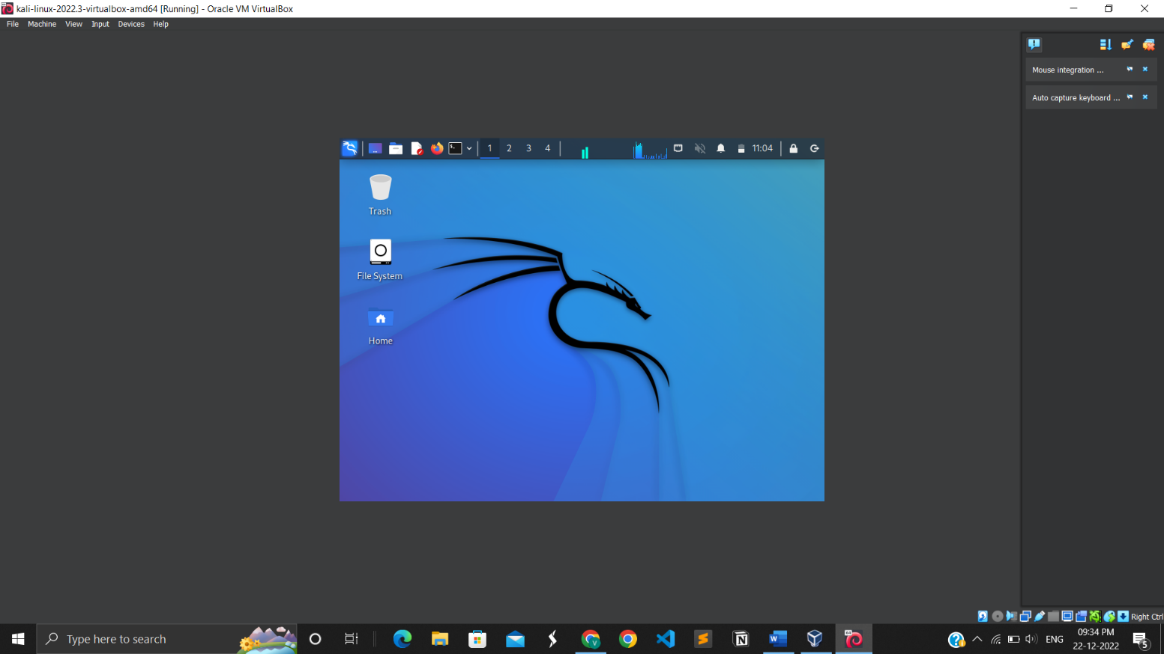

1.8 Finally Kali OS installed

**Features of Parrot OS**

* Lightweight
* Free
* Secure

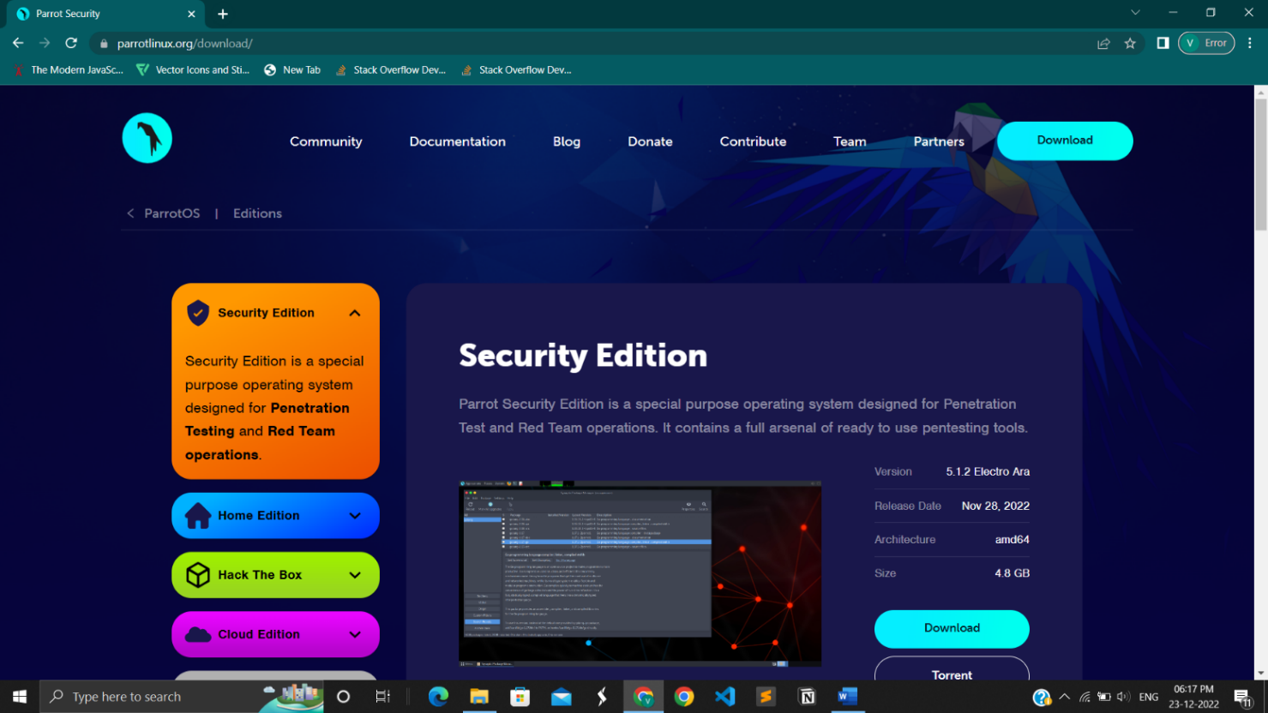

1.9 Official website of Parrot OS to download

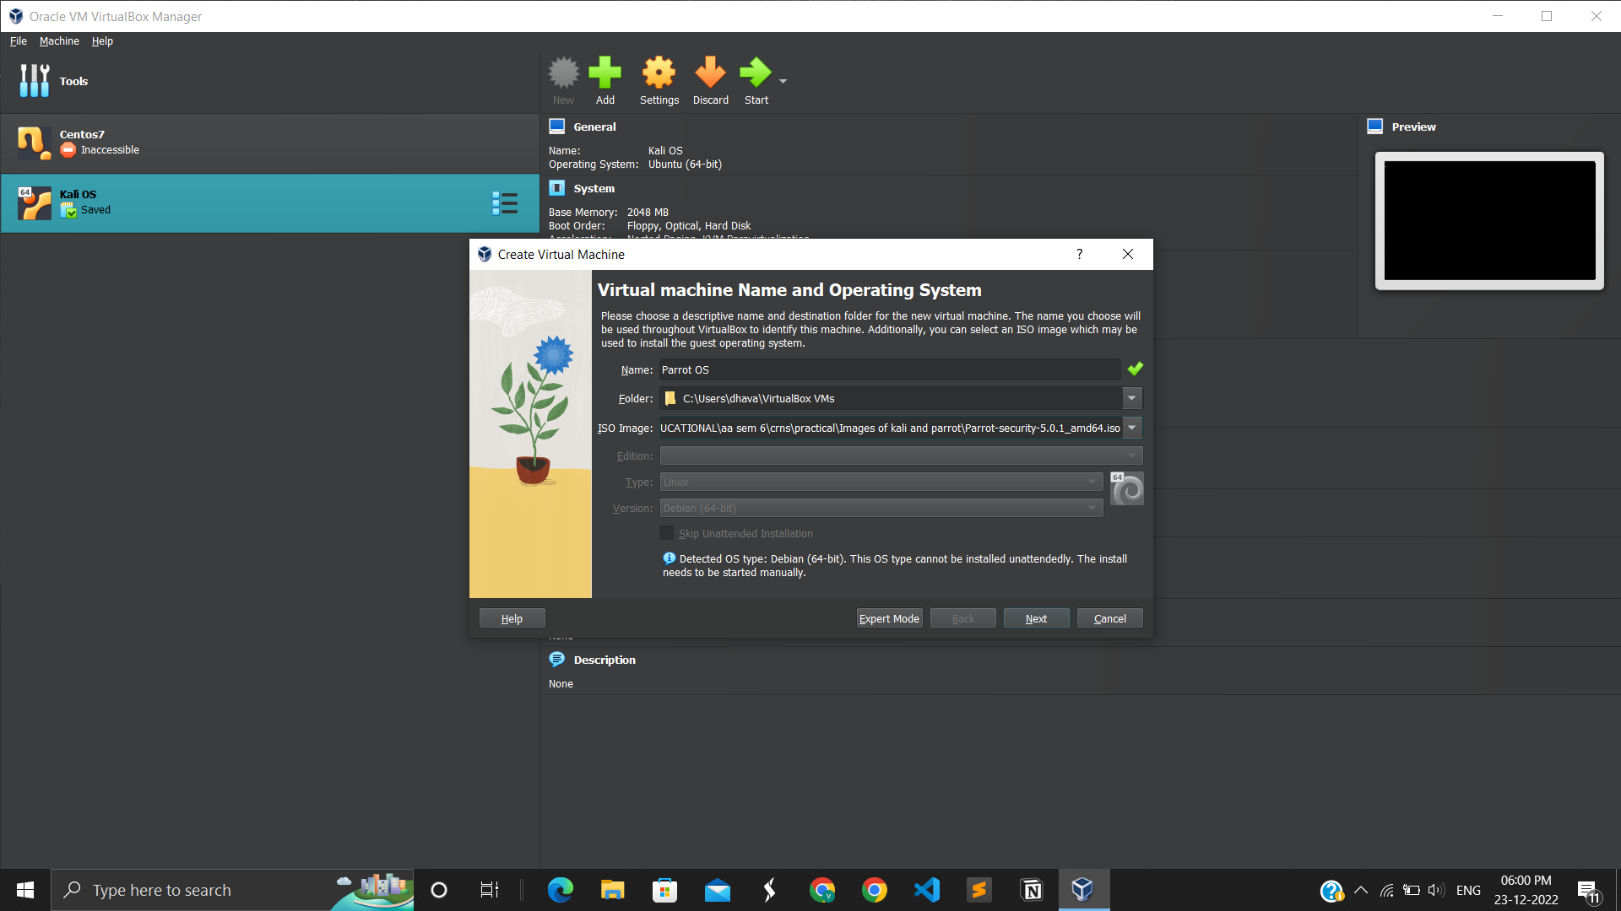

1.10 Give name and address of ISO image of parrot OS

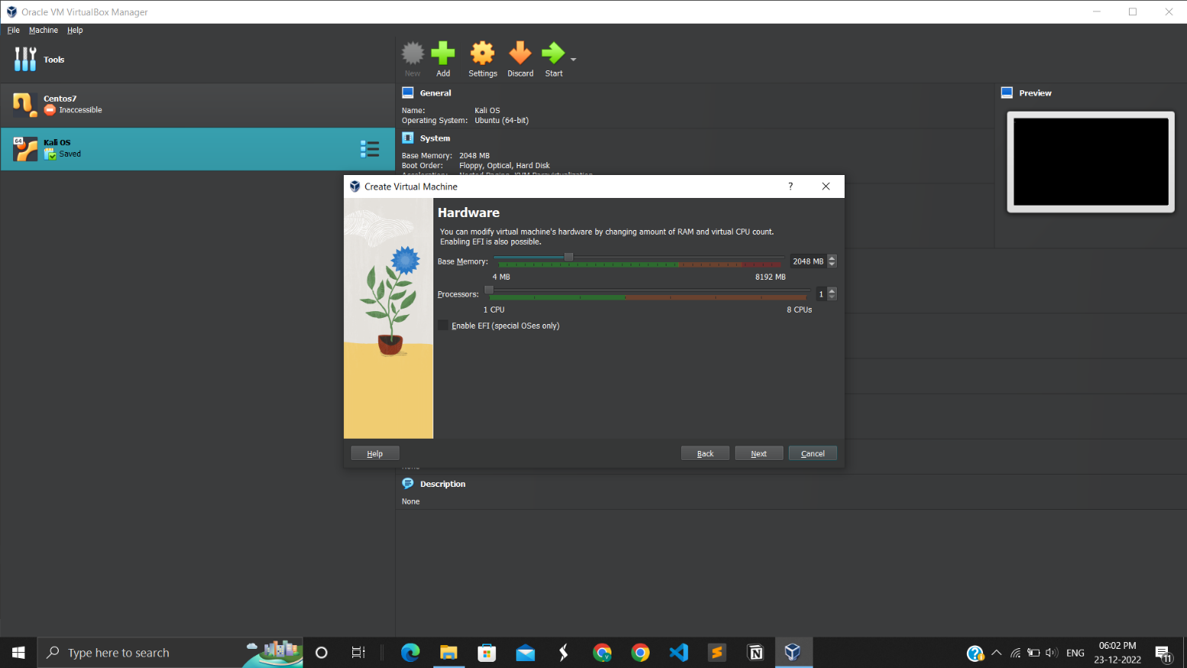

1.11 Adjust Hardware and Processors

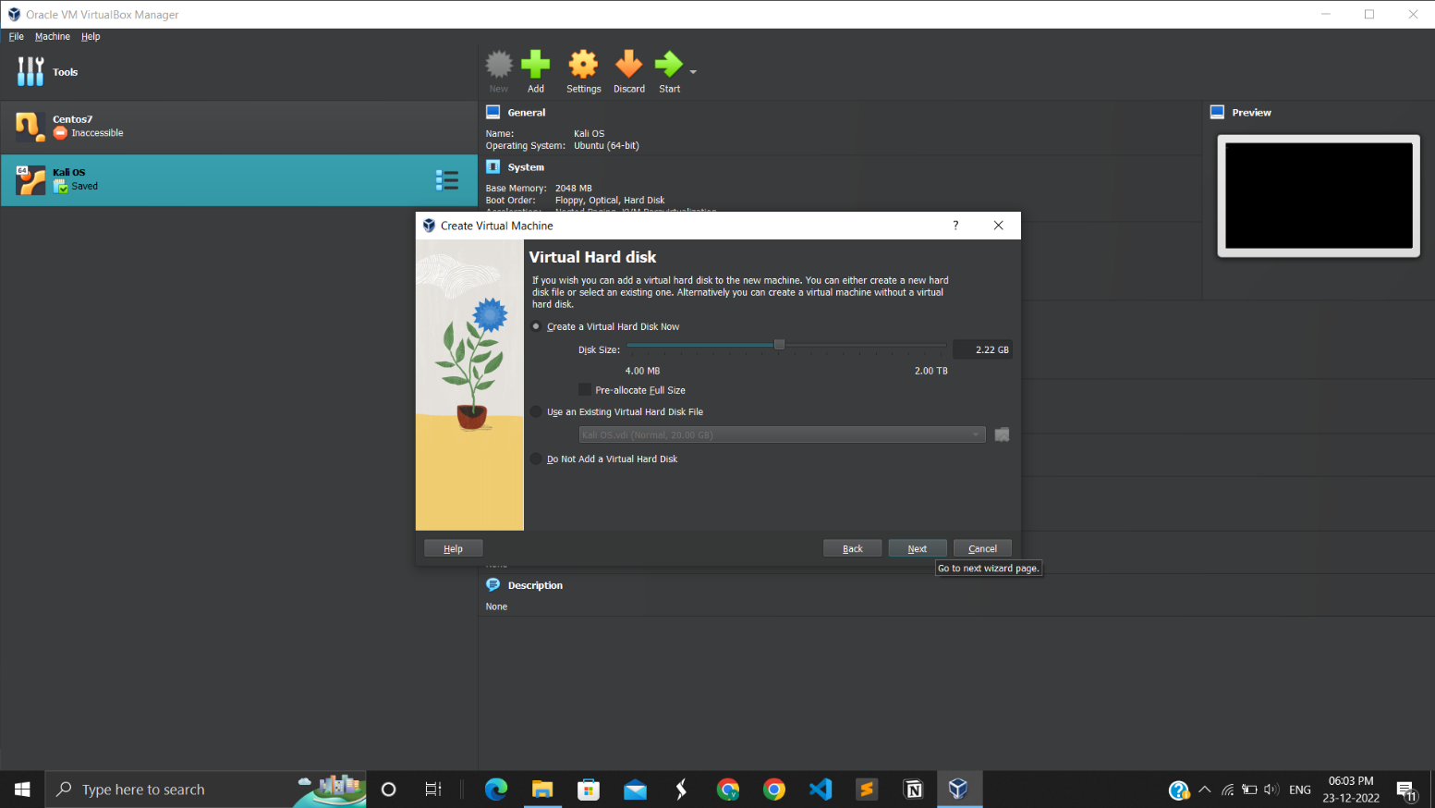

1.12 Adjust Virtual Hard Disk.

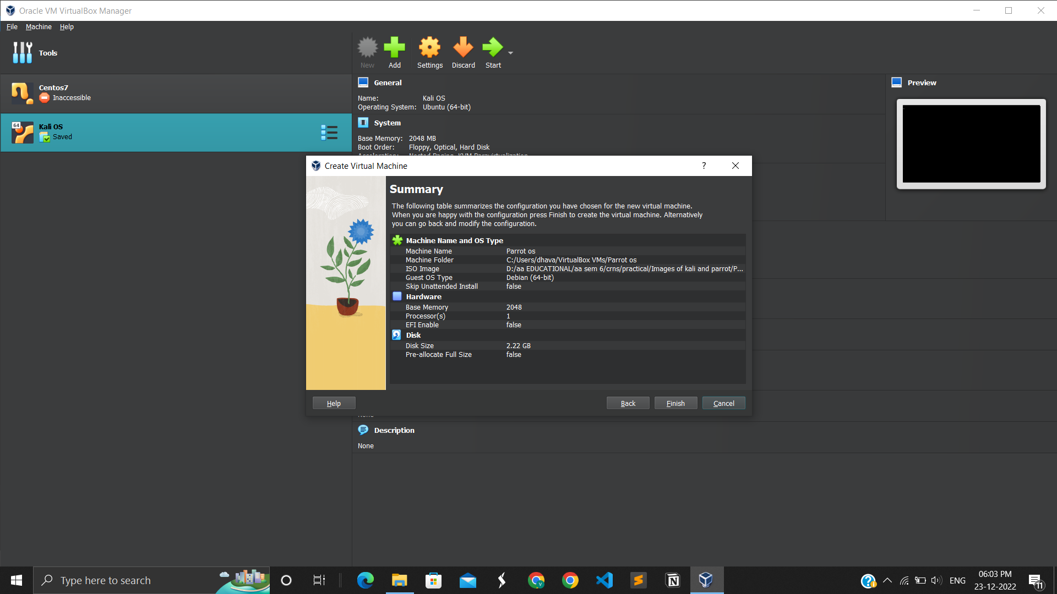

1.13 Summary of Parrot OS

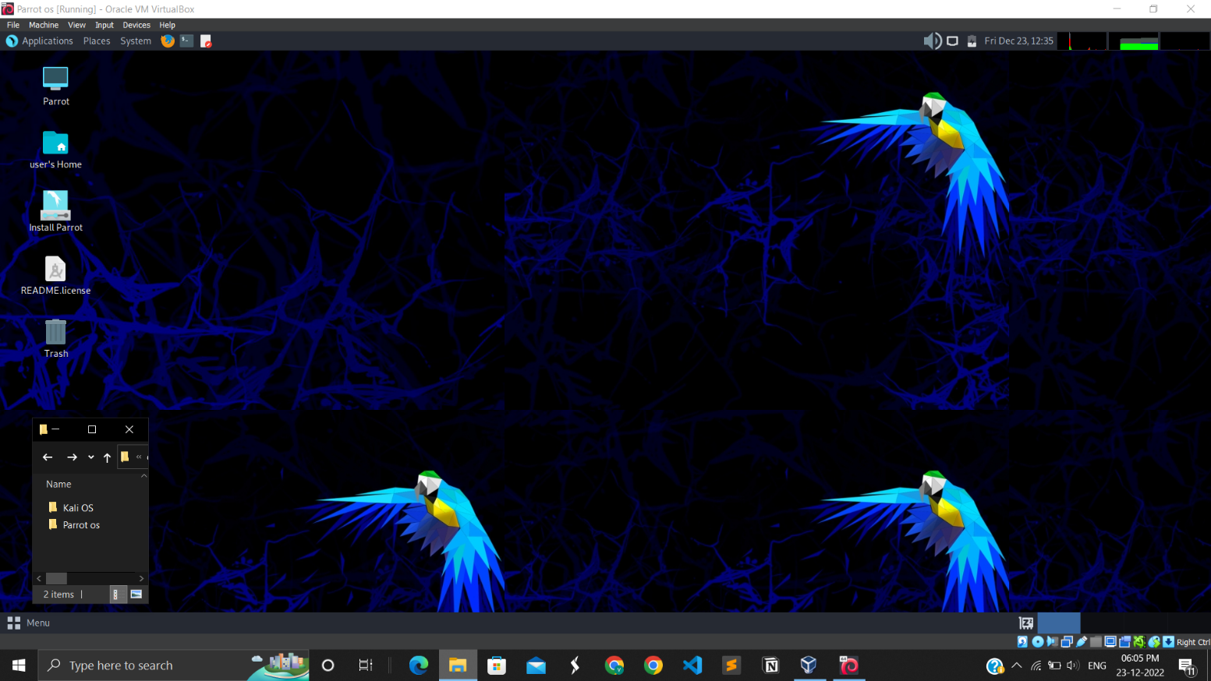

1.14 Desktop of Parrot OS

**DIFFERENCE:**

|  |  |
| --- | --- |
| **Kali Linux** | **Parrot OS** |
| It needs more RAM, about 1 GB. | Only about 320 MB. |
| 20 GB free space for installation. | 16 GB free space for installation. |
| Simpler user interface. | Much better user interface. |
| All basic tools needed for hacking. | Tools that are available in Kali and also adds its own tools. |

**LATEST APPLICATIONS:**

• Introducing the first "real" Kali Linux mobile phone release (Pine Phone/Pro) with Kali NetHunter Pro.

• Internal Bluetooth support, video kernel porting, firmware updates, and other enhancements in Kali NetHunter.

• Parrot OS can be used as the dual boot configuration.

**LEARNING OUTCOME:**

• Differentiation between Parrot OS and Kali Linux.

• Configuration settings while installing both the OS relevantly for better performance.

**REFERENCES:**

1. Kali OS: <https://www.kali.org/>
2. Kali OS Installation: <https://www.youtube.com/watch?v=jk2KGdJU2OI>
3. Parrot Security OS: <https://parrotlinux.org/>
4. Parrot Security OS Installation: <https://www.youtube.com/watch?v=4qvFp99rfXw>
5. Parrot OS documentation: <https://parrotsec.org/blog/2022-09-24-parrot-5.1-release-notes/>
6. Kali linux documentation: <https://www.kali.org/>